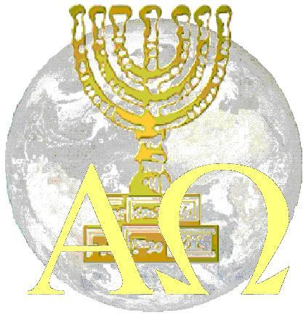
Christians Seeking Identity
Introduction
The universal questions that every human being has asked in frustration at one time or another are “Who am I?” “What is the purpose of my life?”

Most Christians are just as frustrated as people who don’t know God. They know about God, but they somehow feel like they don’t know Him. They lack peace and joy and are continually searching for the revelation that will bring a sense of destiny and fulfillment to their lives.

Why do we long to be with God, long to be holy, long to be righteous, long to know Him? It is because we were created in the image of God. Until we have an understanding of who we were created to be, according to the truth of His word, and not according to ignorance, religion or tradition, we will long to be who we really are.

This course is designed to answer these questions and to bring a sense of destiny, purpose and fulfillment to you. It is designed to show you who you are!

Listed below are the ten lessons with a short summary of each.

- The Foundations are out of Course Man was created to walk in righteousness, covered by the image of God. The foundation (the original intent of God) is out of course (twisted from the truth.)

- Are You Sin Conscious or are you God Conscious? Is your value based on examining yourself and assessing your personal performance according to the Law of the Old Testament, or is it based on examining what God has provided for you through the perfect sacrifice according to the Covenant of the New Testament? Most of us are a mixture of both and it has caused frustration in the body of Christ.

- The Mystery of the Gospel The mystery of the gospel is “Christ in you, the hope of glory.” God wants us to begin to understand that it is His righteousness in us that enables us to perform.

- The Mystery of Iniquity There is an enemy of righteousness at work which presents a form of godliness as truth, but has no power to work righteousness.

- Revealed by the Spirit The function of the Holy Spirit is not to point out every fault in us, but to reveal to us who we really are, to reveal to us the true nature of God and to change us into the image of God.

- What Does it Take to Be God Conscious? The Bible says that we “Walk after the flesh, but we do not war (contend with carnal inclinations) after the flesh. What do we combat sin consciousness with?

- Armed with His Nature Our sustaining strength comes from the “Power of His Might.”

- Go and Take Dominion God created man in His image to act on His behalf according to His word to take dominion over the earth and to fill all of the earth with the knowledge of the glory of the Lord.

- The Will of God Jesus said if we ask anything according to His will, it will be done. We can begin to do the work of God and expect results according to His word when our knowledge regarding His purpose and intent is correct.

10. Commitment We have failed to be committed to God because
we have failed to see how committed He is to us.

